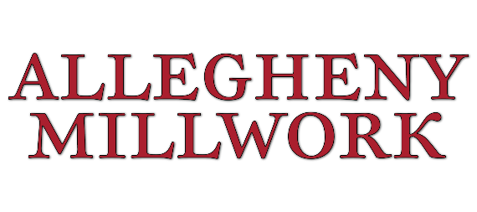

PRE-TASK PLAN

Complete this form before starting work each day or whenever the task, crew, location or conditions change. Review with the entire crew. All workers must sign in. Keep at the work area.

Project & Task Information
Project Name |  | Date
General Contractor |  | Shift/Time
Location/Floor/Room |  | Building Occupied? | ☐Yes ☐No
Superintendent |  | Phone Number
Task Description
Scope of Work

Crew Sign-In & Training Verification
# | Name | Role | Training Current | Signature | Initials
1 |  |  | ☐Yes ☐No
2 |  |  | ☐Yes ☐No
3 |  |  | ☐Yes ☐No
4 |  |  | ☐Yes ☐No
5 |  |  | ☐Yes ☐No
6 |  |  | ☐Yes ☐No
7 |  |  | ☐Yes ☐No
8 |  |  | ☐Yes ☐No
9 |  |  | ☐Yes ☐No
10 |  |  | ☐Yes ☐No

Job Steps/Hazards/Controls (JHA)
# | Task Step/Activity | Potential Hazards | Controls/Safe Work Practices | Risk Level  (H/M/L)
1
2
3
4
5
6
7
8
9
10
11
12

High: Stop & Escalate | Medium: Additional Controls Required | Low: Standard Controls

Hazard Identification Checklist (Check All That Apply)
☐Working at heights/ladders/scaffold | ☐Silica Dust (cutting, grinding, drilling)
☐Mobile elevated work platforms (scissor/boom) | ☐Lead, asbestos, or mold (pre-1980 building)
☐Floor/wall openings | ☐Welding/cutting/hot work
☐Slips, trips, falls (cords, debris) | ☐Spray painting/coatings/VOCs
☐Falling objects/overhead work | ☐Adhesives, sealants, solvents (SDS reviewed)
☐Housekeeping/egress blocked | ☐Confined Space (crawlspace, attic, plenum)
☐Live electrical (LO-TO required) | ☐Hand & Power Tool hazards
☐Temporary Power/GFCI | ☐Pneumatic/powder-actuated tools
☐Energized panels nearby | ☐Material handling/manual lifting
☐Occupied building – public/tenant exposure | ☐Adjacent trades working overhead/below
☐Life safety systems impaired (fire alarm, sprinkler) | ☐Hot work permit required
☐ICRA: Infection Control (healthcare) | ☐Confined Space permit Required
☐Noise/vibration impact to occupants | ☐Energized work permit/LO-TO required
☐Dust containment/negative air required | ☐After-hours work/weekend work

Required Personal Protective Equipment (PPE)
☐Hard Hat | ☐Safety Glasses | ☐Hearing Protection
☐Safety-Toe Footwear | ☐Hi-Viz Vest | ☐Cut-Resistant Gloves
☐Chemical-Resistant Gloves | ☐Face Shield | ☐Welding Hood/Leathers
☐Respirator (___________) | ☐Fall Protection Harness | ☐Self-Retracting Lifeline
☐Knee Pads | ☐Tyvek/Coveralls | ☐Other: _____________

Permits, Inspections & Required Documents
☐Hot Work Permit | ☐Confined Space Entry Permit
☐Energized Electrical Work Permit/LO-TO | ☐Above Ceiling/Ceiling Access Permit
☐Fire Watch Designee: ________________ | ☐Fire Alarm Impairment Notice
☐Sprinkler Impairment Notice | ☐Roof/Penetration Permit
☐ICRA Permit (Healthcare) | ☐ILSM Plan in Place (Healthcare)
☐SDS Reviewed for Chemicals on Site | ☐Inspection of Ladders/Scaffolds/MEWP Complete
☐Daily Equipment Pre-Use Inspection (Forklift, MEWP) | ☐Excavation/Penetration Locate Complete

Emergency Information
Nearest Hospital |  | Hospital Phone
Hospital Address
Muster/Assembly Point |  | Site Emergency Contact
Nearest Exit |  | Fire Extinguisher Location
First Aid/AED Location |  | Eye Wash Station Location
Emergency Number | 911 | Superintendent

Changes in Conditions/Stop-Work Authority
EVERY WORKER HAS STOP-WORK AUTHORITY.
If conditions change, a new hazard appears, scope changes or anything feels unsafe; STOP work, notify the Superintendent & revise this PTP before resuming.
Changes During Shift
Near Miss/Incident
Lessons Learned/Good Catch:

Review & Approval
Role | Name (Print) | Signature | Date/Time
Superintendent
Project Safety Rep
GC Superintendent
Other:

